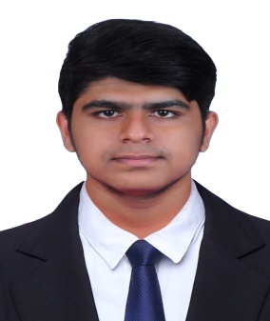SATHYA NARAYANAN K R

## Mobile No : 9360101315

**Email : sathivrs2208@gmail.com**

**LinkedIn :** [**https://www.linkedin.com/in/sathya-narayanan-k-r-2b1639255/**](https://www.linkedin.com/in/sathya-narayanan-k-r-2b1639255/)

**GitHub :** https://www.github.com/wake_awake

# CAREER OBJECTIVE:

Motivated Computer Science undergraduate seeking opportunities to contribute technical skills and grow professionally in a dynamic organization.

# ACADEMIC BACKGROUND:

|  |  |  |  |
| --- | --- | --- | --- |
| **Qualification** | **School / College** | **Year of**  **Passing** | **Percentage/CGPA** |
| B.E  (Computer Science) | Karpagam Academy of Higher Education | 2022 - 2026 | 7.5  *(Up to 6th semester) |
| HSC | AGN Matriculation Higher Secondary School | 2022 | 83.1 |
| SSLC | Dheeran Academy (CBSE) | 2020 | 76.6 |

**TECHNICAL SKILLS:**

* Programming Languages : C,C++,Java, python
* Web Technology : HTML, CSS, JavaScript, React.js
* Tools & Platforms : Git, GitHub, VS Code, Eclipse
* Database Technology : SQL (Basic) – CRUD operations, Joins, and basic query writing

# PERSONAL SKILLS

* Logical Thinking
* Growth Mindset
* Creativity

# AREA OF INTEREST

* Problem Solving
* Web Development
* Algorithms

# CERTIFICATION

* Certified in Introduction to Programming in C by NPTEL during Jan-Mar 2023.
* Certified in Introduction to MongoDB by MongoDB during 2024
* Certified in DATABASE AND SQL by Infosys Springboard during 2024.

# PROJECT

# Schedule Tracker: A task management web app that helps users organize and prioritize their tasks.

Time: [May 2025]

* Tech Stack: React.js, HTML/CSS, JavaScript, Local Storage
* Integrated authentication logic using local storage to manage user sessions securely on the client side.
* Created a dynamic navigation flow with proper route protection—users are redirected to the Home Page upon logout.
* Contributed to both front-end structure and team collaboration by managing routing, layout, and state management.

# INTERNSHIP

Web Development Trainee - Intech Digital Solutions

Time: December 2023 (15 days)

* Built responsive web pages using HTML5/CSS3.
* Implemented DOM manipulation with JavaScript Basics.
* Completed certification in Frontend Development Basics.

# PERSONAL DETAILS

Date of Birth: 22/09/2005

Father’s Name: Rajavel T

Hobbies: Reading books, Listening Music

Address: 4/444, Kundalpatti, Sankagiri, Salem, Tamil Nadu -637301

# DECLARATION

# I hereby declare that the information provided in this resume is true and accurate to the best of my knowledge and belief.

DATE:

PLACE: Coimbatore